1. 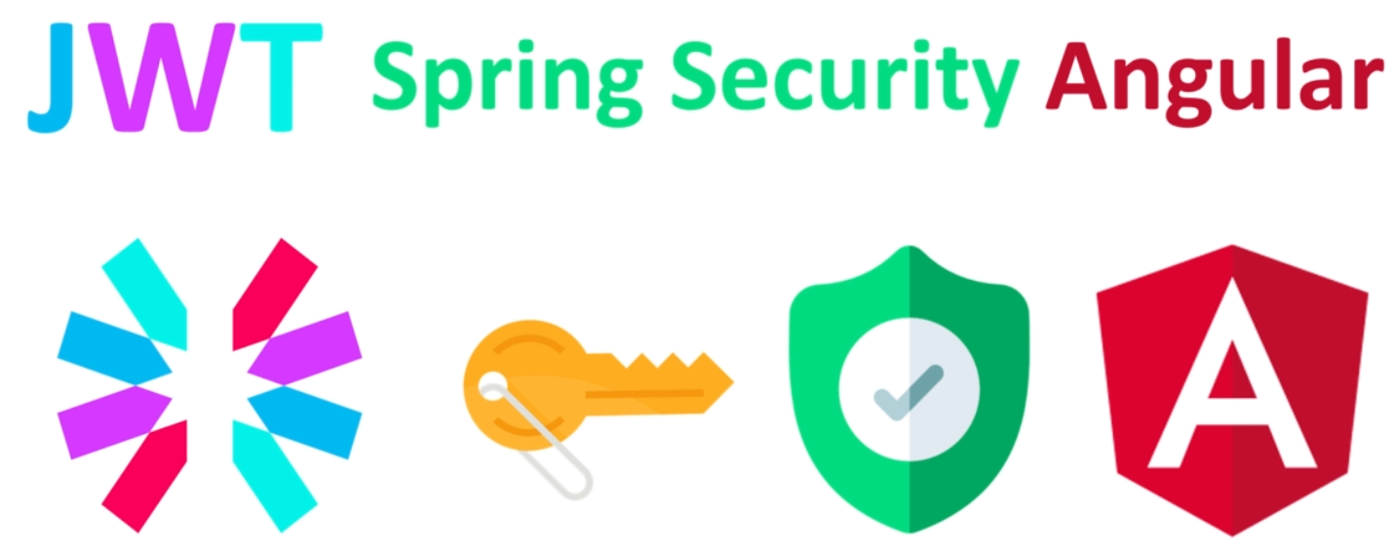
2. 
3. **JWT**: JSON Web Token is a way to create an access token to communicate with a secure API.
4. We will see how to
   1. Create them.
   2. Sign them
   3. Pass them to users logging into your app.
5. We will combine all of these technologies with spring security so that we can create a modern secure back-end app commonly known as API.
6. When our back-end app is up and running, we will build a front angular app.
7. **The goal of this app**:
8. Skipped